Freeform Shapes
# Source: AI Source: Provided by: [Data Path: Persons Table -> ID Column: 1, Name_En Column: Motasem Essam] -> From: [ChatGPT] on [7/25/2026]
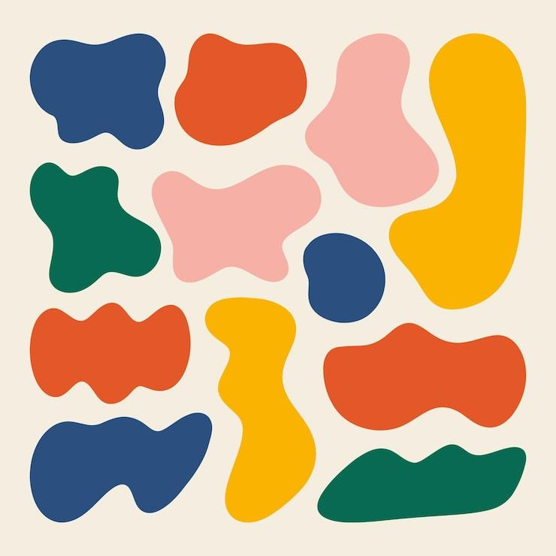
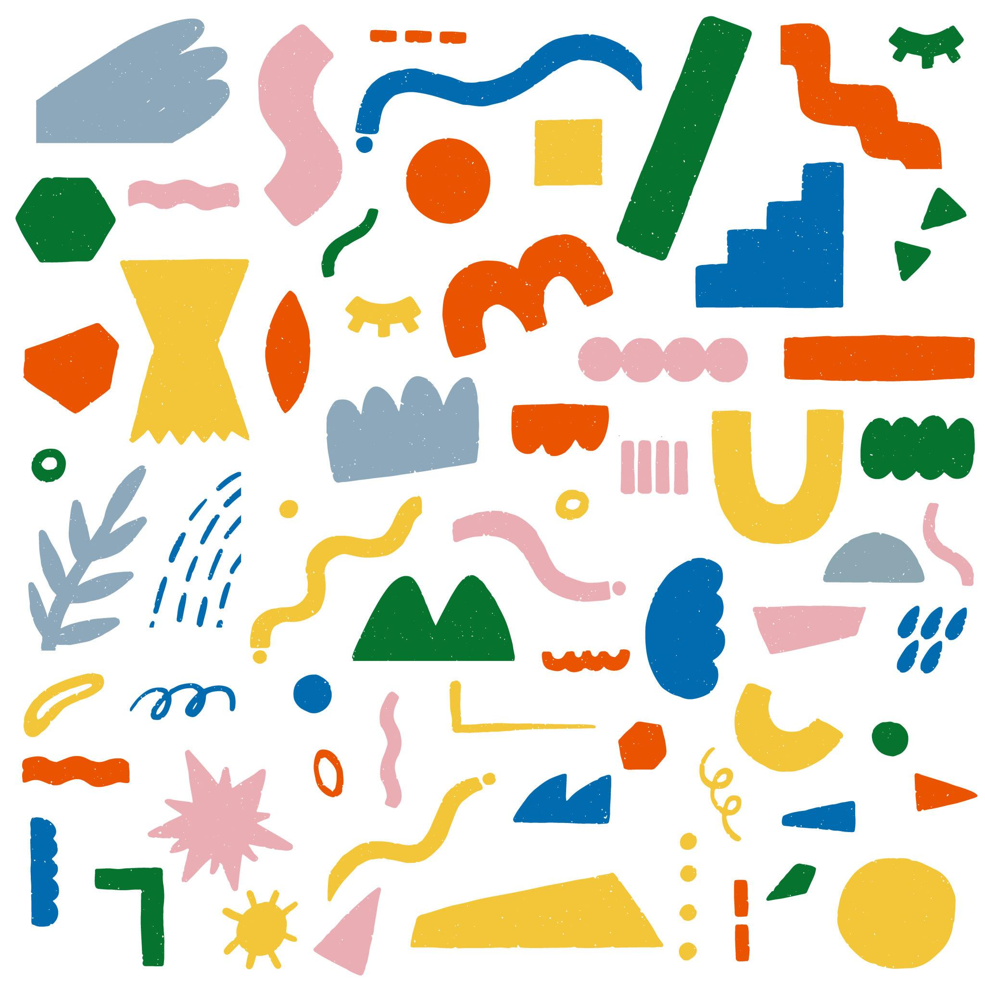
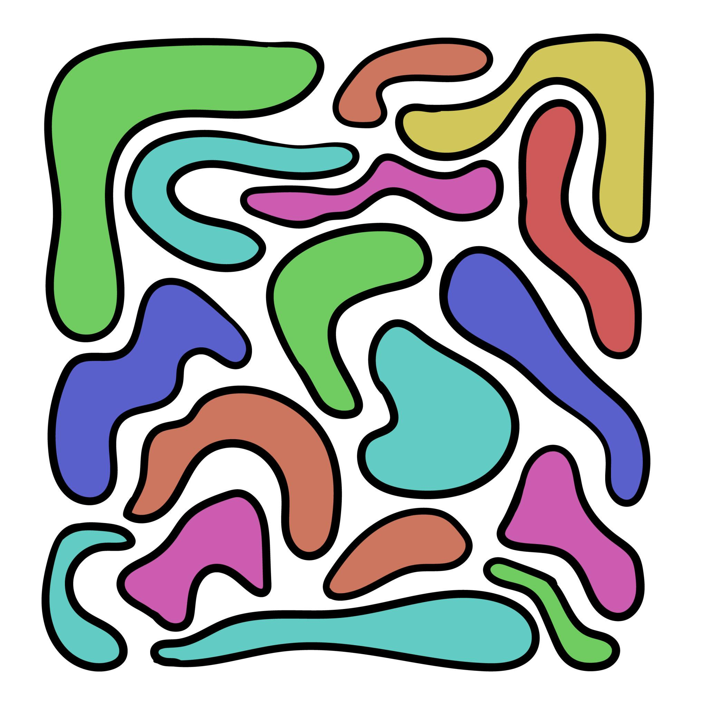
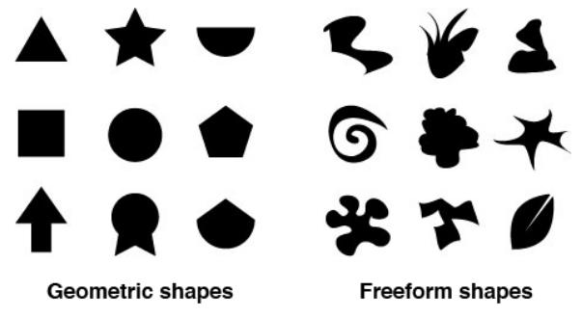
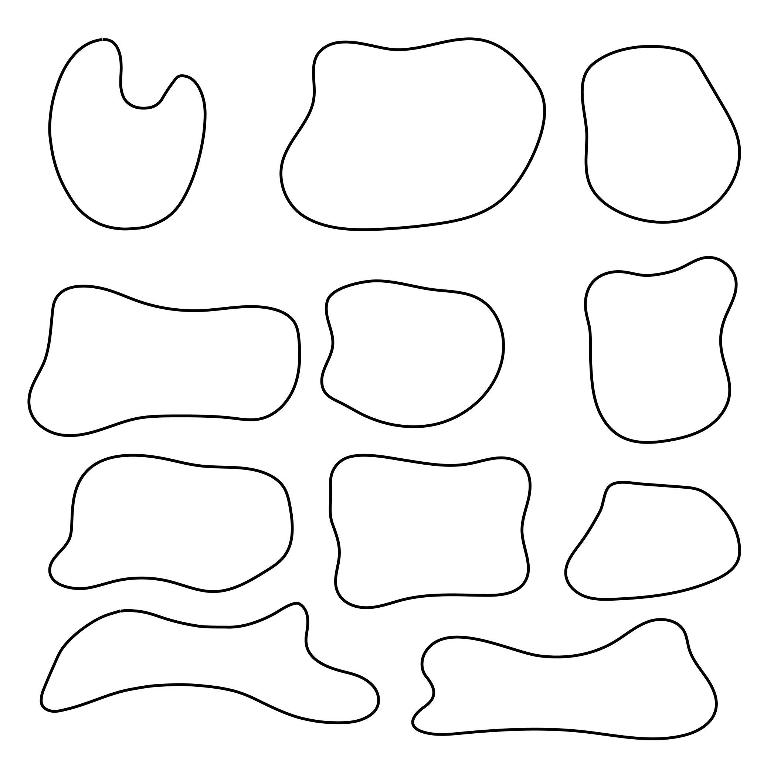
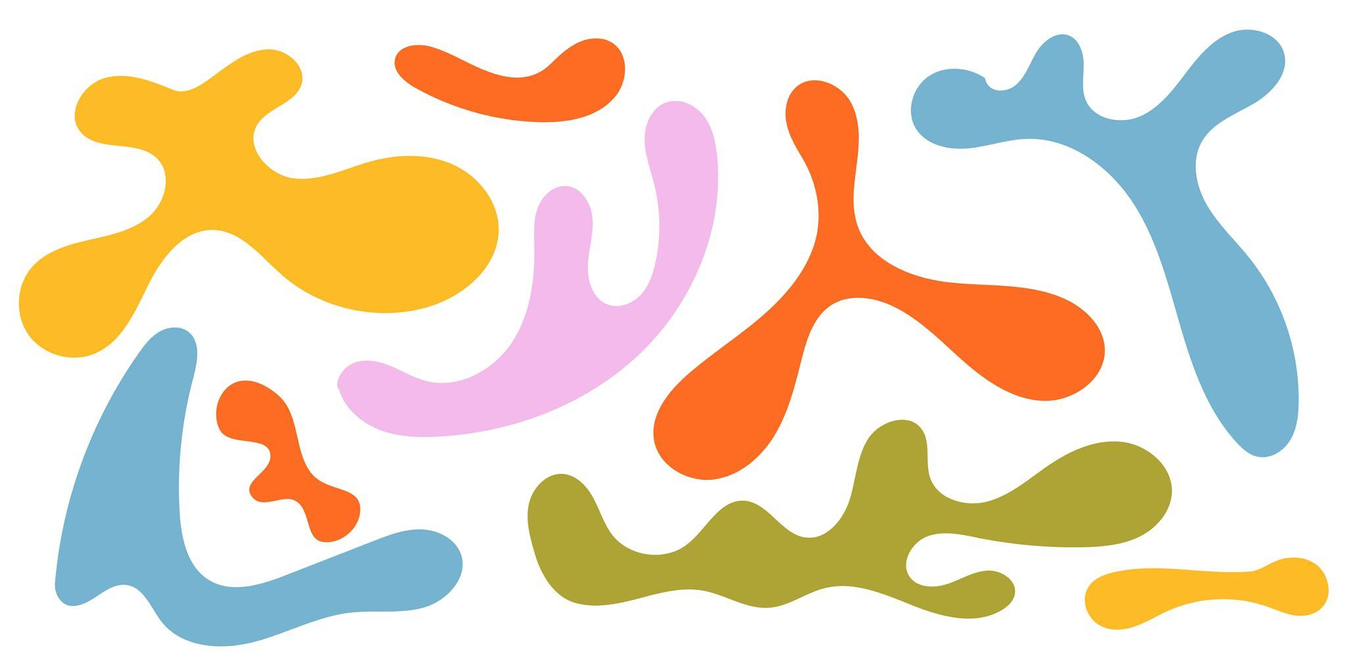

Definition
# Source: AI Source: Provided by: [Data Path: Persons Table -> ID Column: 1, Name_En Column: Motasem Essam] -> From: [ChatGPT] on [7/25/2026]
A Freeform Shape is a shape whose boundary does not follow a fixed, standard geometric form or a predetermined regular pattern.
Freeform shapes are typically created using irregular curves, lines, or combinations of different boundary elements to produce a flexible, non-standard outline.
Unlike geometric shapes such as circles, triangles, and rectangles, freeform shapes are not generally defined by a specific set of mathematical dimensions, angles, or symmetry requirements.

Fundamental Concept
# Source: AI Source: Provided by: [Data Path: Persons Table -> ID Column: 1, Name_En Column: Motasem Essam] -> From: [ChatGPT] on [7/25/2026]
The main characteristic of a freeform shape is freedom from a prescribed geometric structure.
For example:
- A circle has a precise mathematical definition.
- A rectangle has four sides and four right angles.
- A freeform shape may have an arbitrary boundary that does not conform to these standard rules.
A freeform shape can therefore be:
- Smooth or irregular
- Curved or partly straight
- Symmetric or asymmetric
- Closed or open
- Simple or complex
- Regular-looking in some parts but irregular overall

Main Characteristics
# Source: AI Source: Provided by: [Data Path: Persons Table -> ID Column: 1, Name_En Column: Motasem Essam] -> From: [ChatGPT] on [7/25/2026]
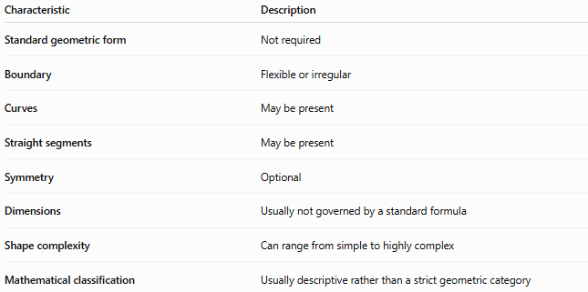
Characteristic | Description
Standard geometric form | Not required
Boundary | Flexible or irregular
Curves | May be present
Straight segments | May be present
Symmetry | Optional
Dimensions | Usually not governed by a standard formula
Shape complexity | Can range from simple to highly complex
Mathematical classification | Usually descriptive rather than a strict geometric category

Types of Freeform Shapes
# Source: AI Source: Provided by: [Data Path: Persons Table -> ID Column: 1, Name_En Column: Motasem Essam] -> From: [ChatGPT] on [7/25/2026]
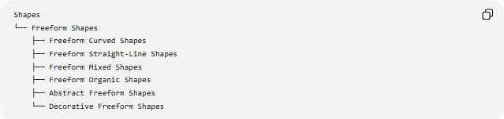
Shapes
└── Freeform Shapes
├── Freeform Curved Shapes
├── Freeform Straight-Line Shapes
├── Freeform Mixed Shapes
├── Freeform Organic Shapes
├── Abstract Freeform Shapes
└── Decorative Freeform Shapes

1-Freeform Curved Shapes
# Source: AI Source: Provided by: [Data Path: Persons Table -> ID Column: 1, Name_En Column: Motasem Essam] -> From: [ChatGPT] on [7/25/2026]
Shapes whose boundaries are primarily made of irregular curves.
Examples:
- Blobs
- Cloud-like outlines
- Fluid shapes
- Irregular rounded forms
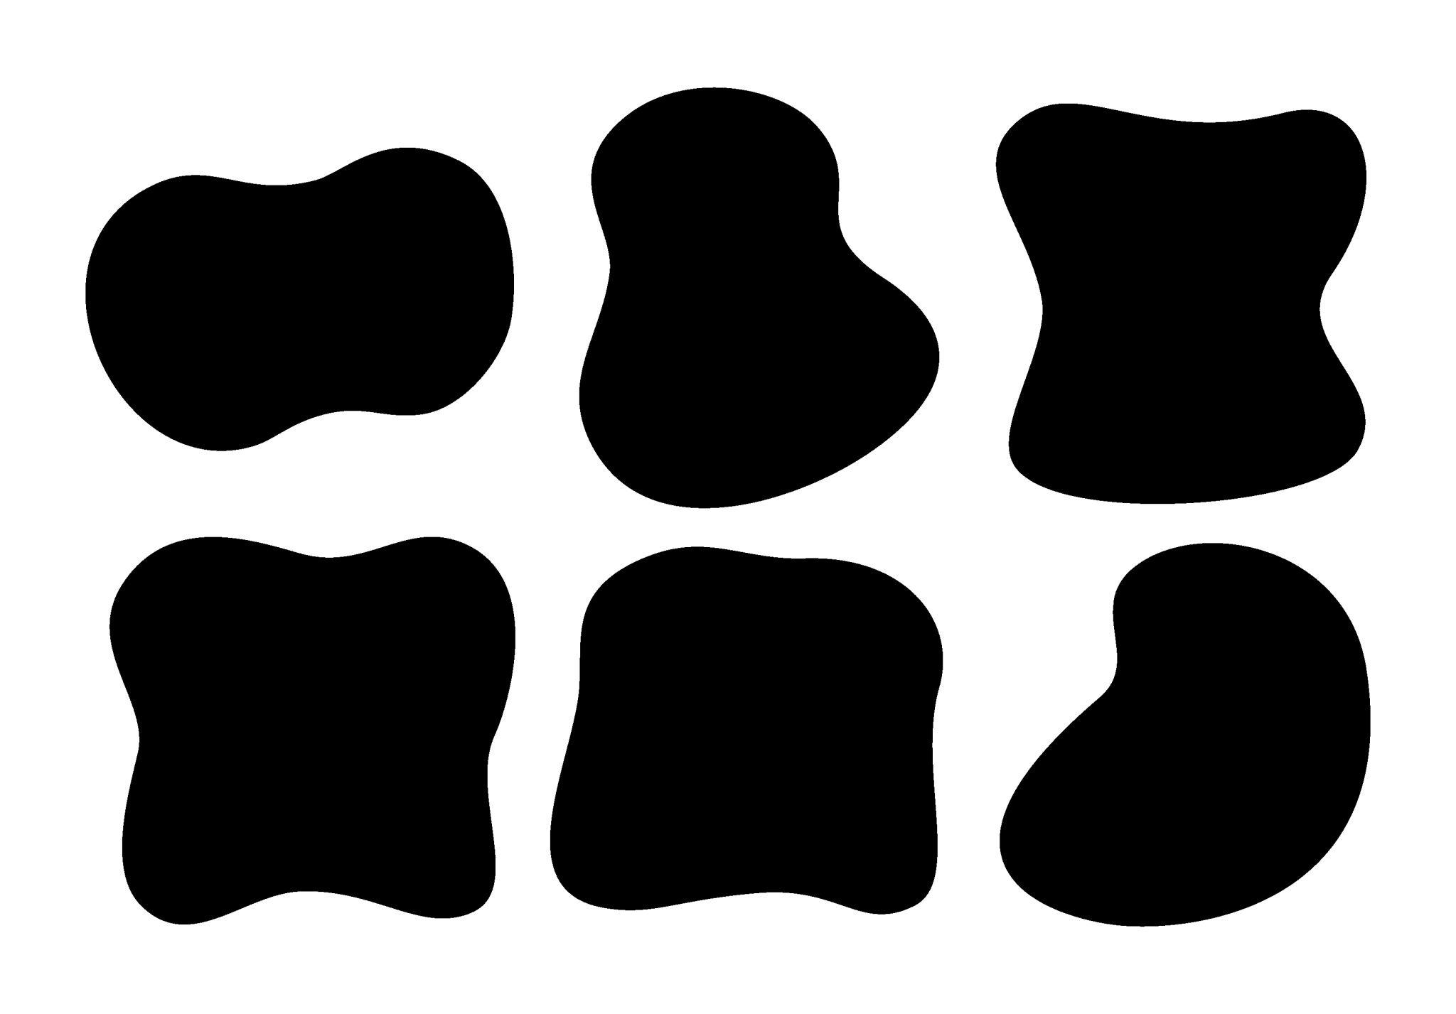
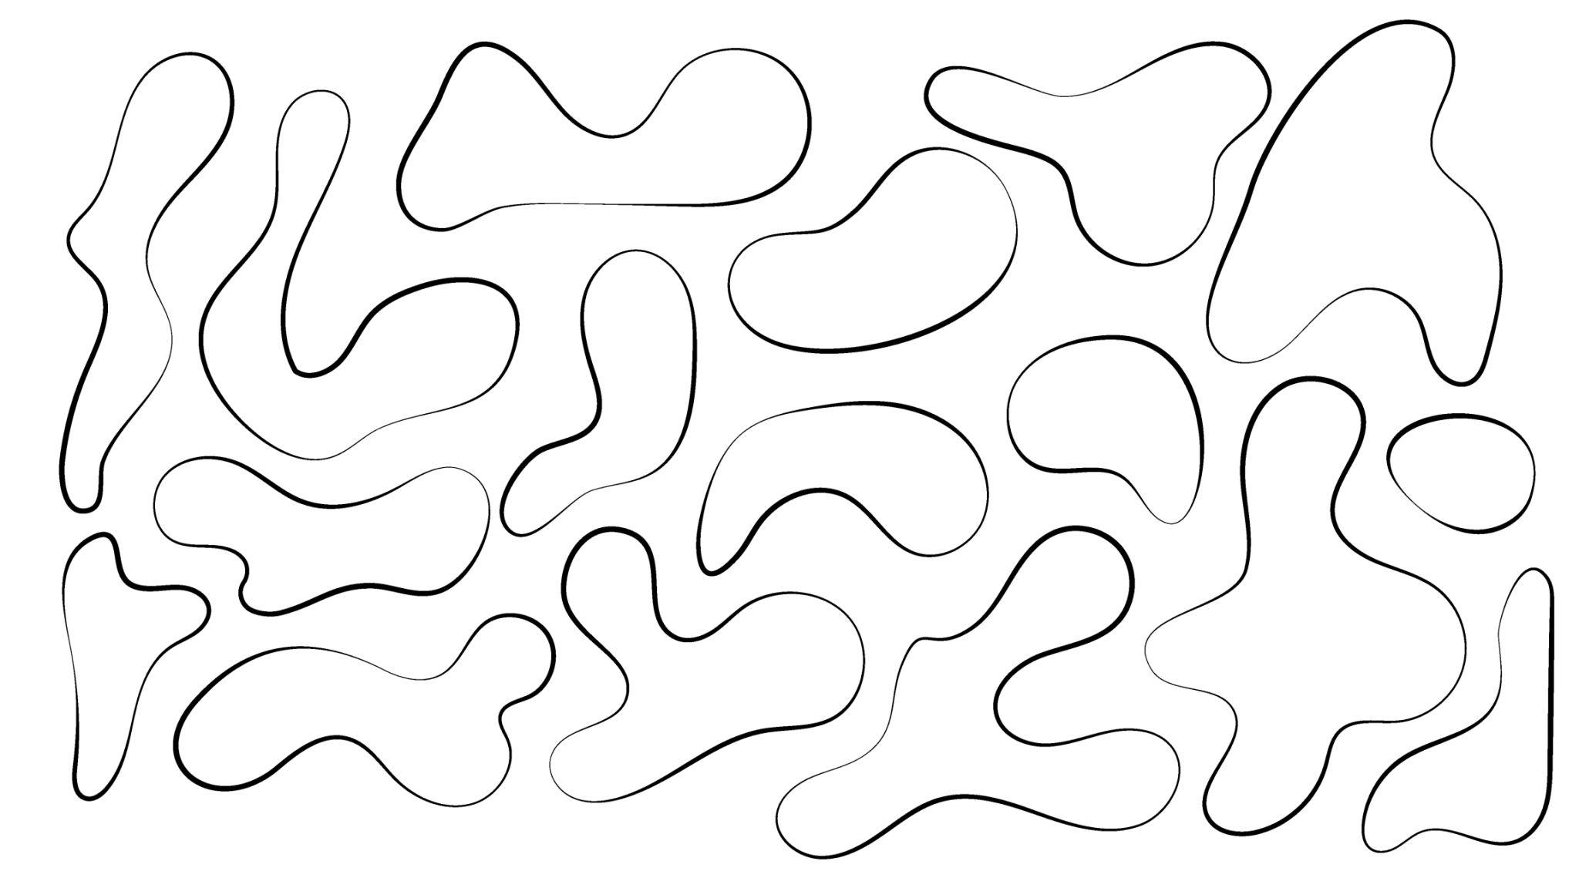
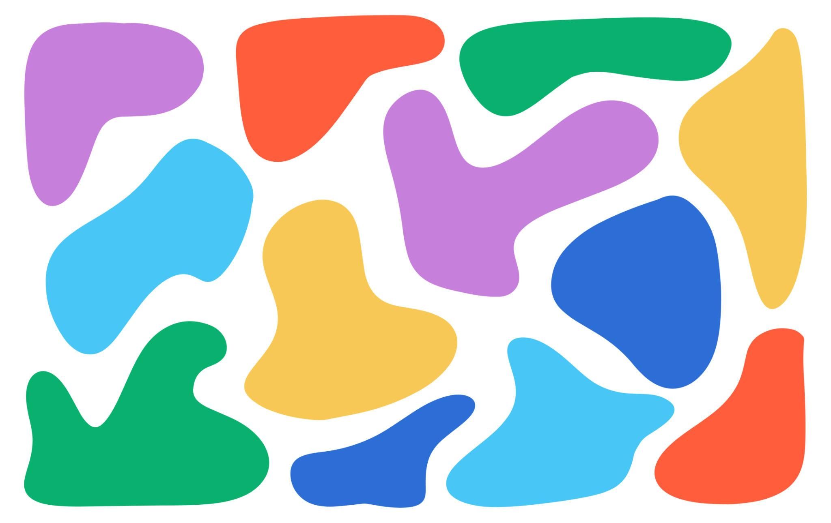
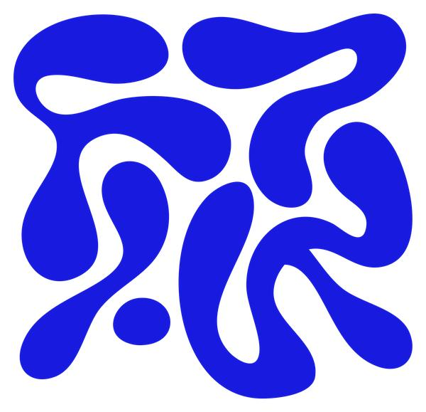

2-Freeform Straight-Line Shapes
# Source: AI Source: Provided by: [Data Path: Persons Table -> ID Column: 1, Name_En Column: Motasem Essam] -> From: [ChatGPT] on [7/25/2026]
Shapes created from irregular straight-line segments without following a standard polygonal pattern.
For example, an arbitrary closed outline made from different-length segments and different angles.

3-Freeform Mixed Shapes
# Source: AI Source: Provided by: [Data Path: Persons Table -> ID Column: 1, Name_En Column: Motasem Essam] -> From: [ChatGPT] on [7/25/2026]
Shapes combining straight lines and curves within the same boundary.
For example:
Straight Segment → Curve → Straight Segment → Irregular Curve
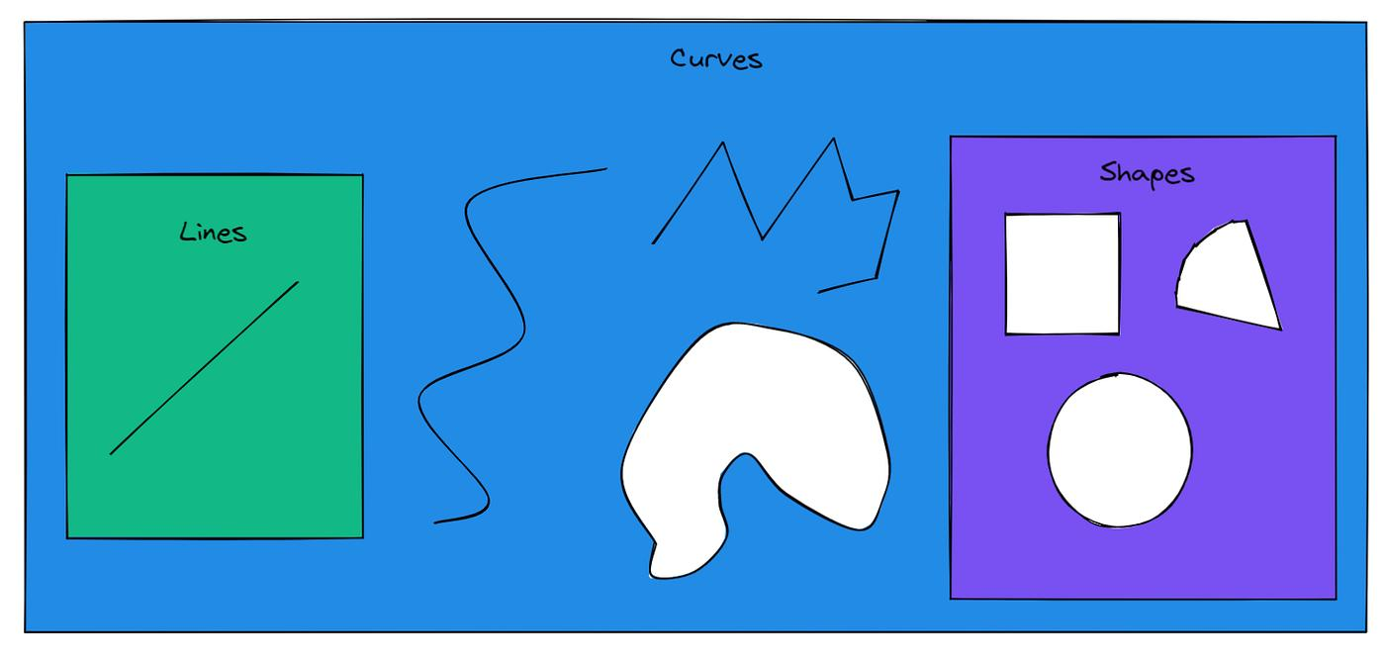
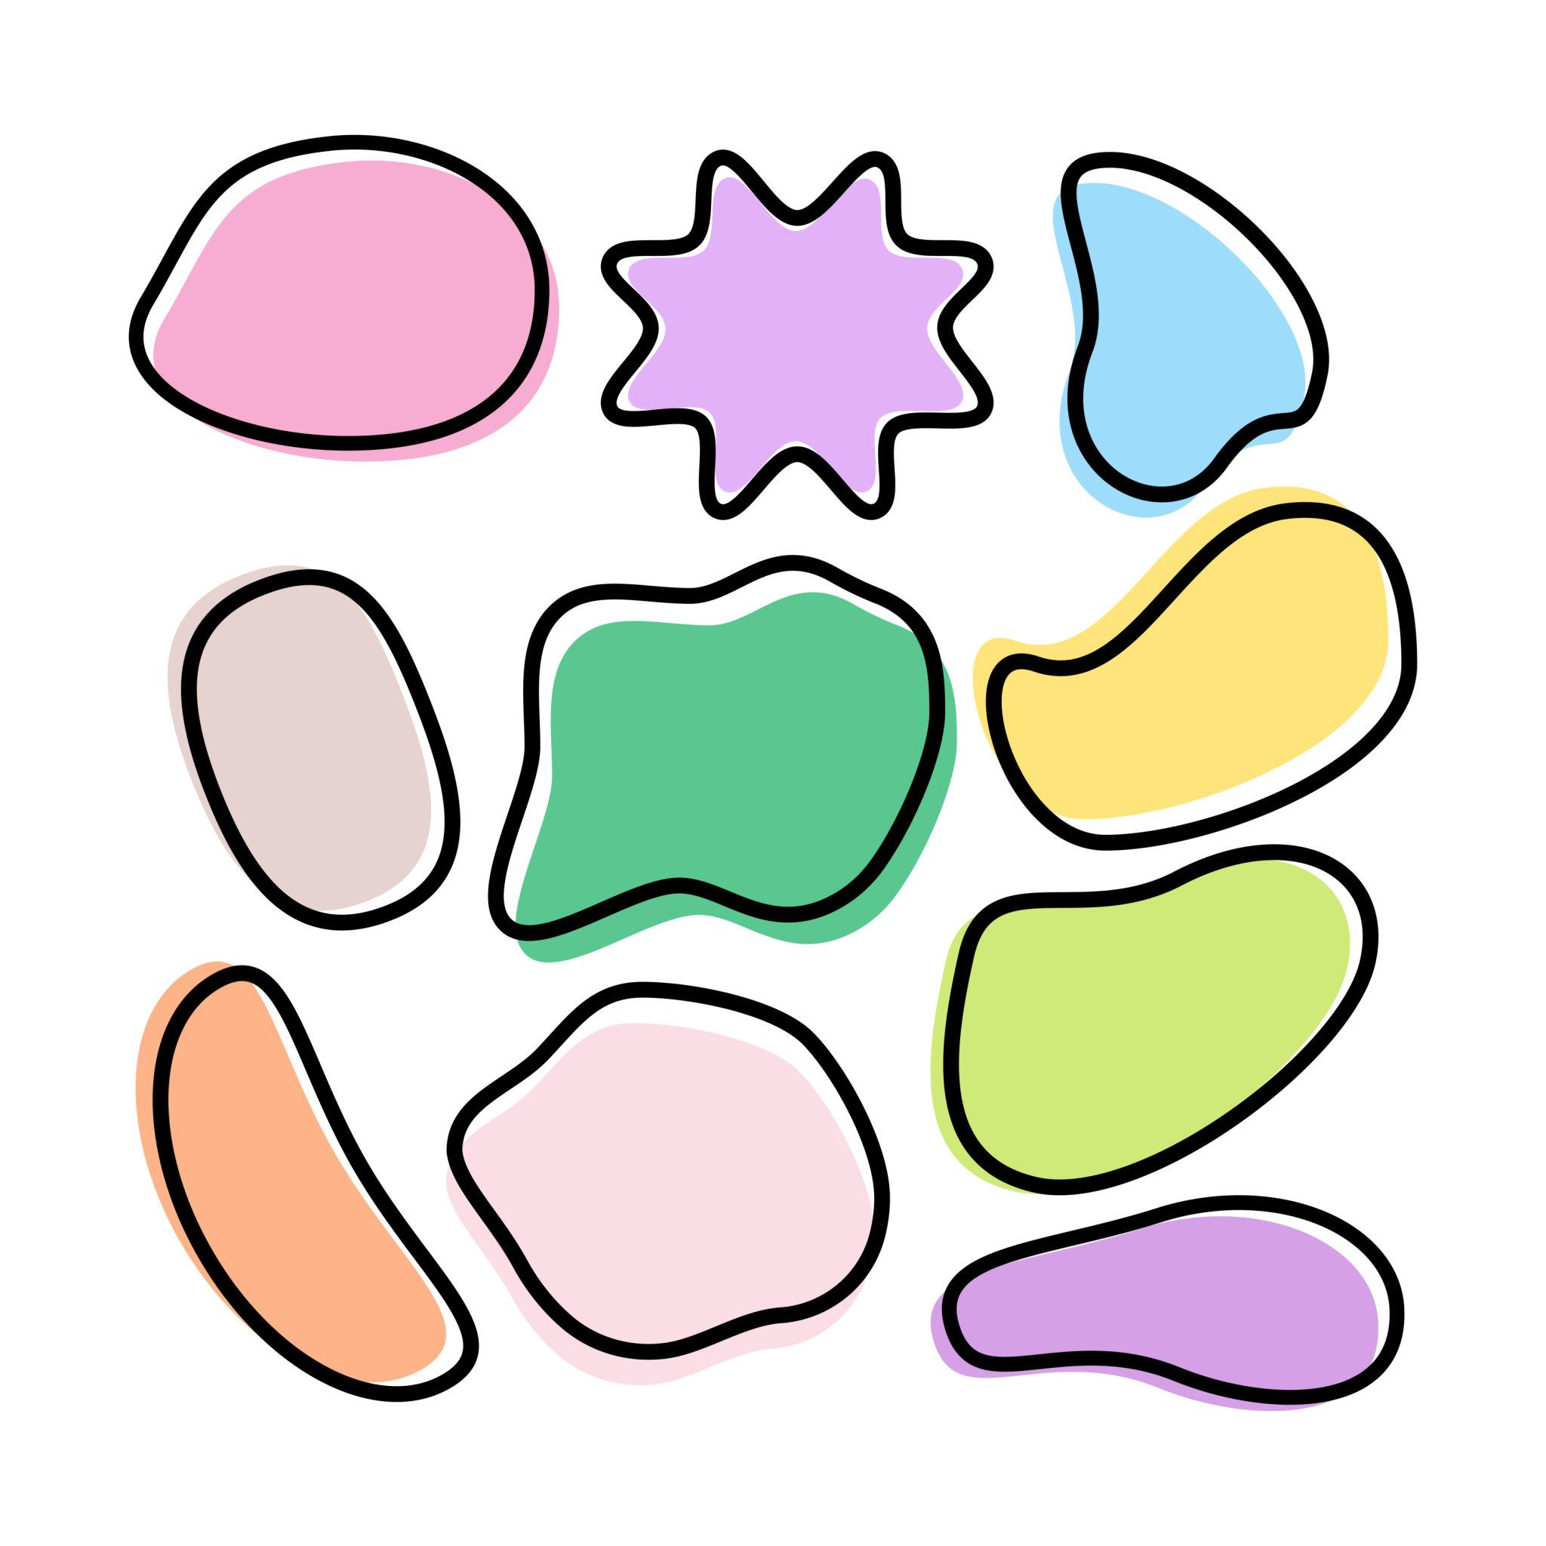
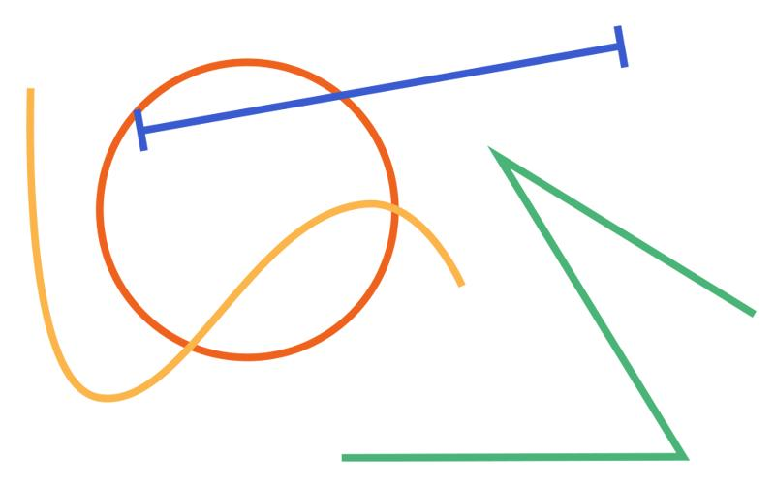
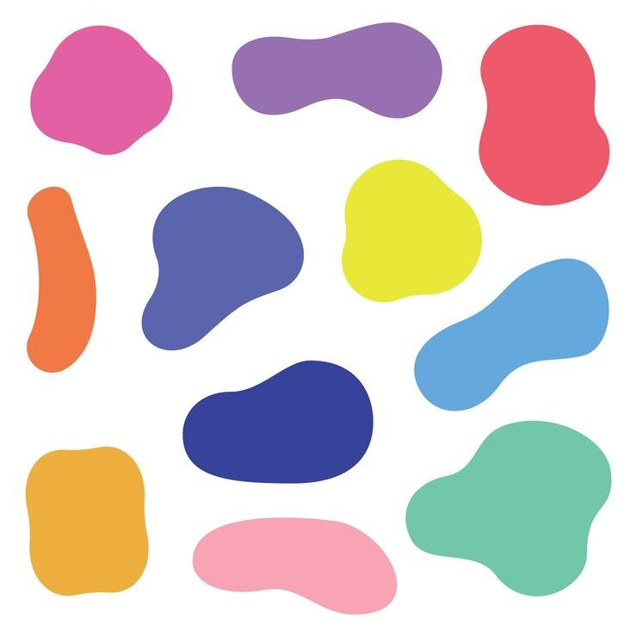

4-Freeform Organic Shapes
# Source: AI Source: Provided by: [Data Path: Persons Table -> ID Column: 1, Name_En Column: Motasem Essam] -> From: [ChatGPT] on [7/25/2026]
Freeform shapes that resemble natural forms.
Examples:
- Leaves
- Petals
- Clouds
- Water splashes
- Natural rock formations
These are a major overlap between Freeform Shapes and Organic Shapes.

5-Abstract Freeform Shapes
# Source: AI Source: Provided by: [Data Path: Persons Table -> ID Column: 1, Name_En Column: Motasem Essam] -> From: [ChatGPT] on [7/25/2026]
Shapes created without representing a specific natural or geometric object.
They are commonly used in:
- Art
- Graphic design
- Logos
- Illustrations
- Digital interfaces

6-Decorative Freeform Shapes
# Source: AI Source: Provided by: [Data Path: Persons Table -> ID Column: 1, Name_En Column: Motasem Essam] -> From: [ChatGPT] on [7/25/2026]
Freeform shapes designed primarily for visual decoration.
Examples include:
- Decorative curves
- Background blobs
- Artistic borders
- Irregular ornamental forms

Open and Closed Freeform Shapes
# Source: AI Source: Provided by: [Data Path: Persons Table -> ID Column: 1, Name_En Column: Motasem Essam] -> From: [ChatGPT] on [7/25/2026]
Freeform shapes can also be classified according to whether their boundaries are closed.
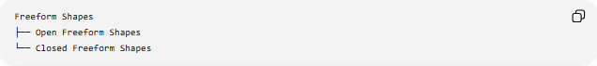
Freeform Shapes
├── Open Freeform Shapes
└── Closed Freeform Shapes
Open Freeform Shape
A freeform boundary whose starting and ending points do not meet.
Closed Freeform Shape
A freeform boundary that returns to its starting point and encloses a region.
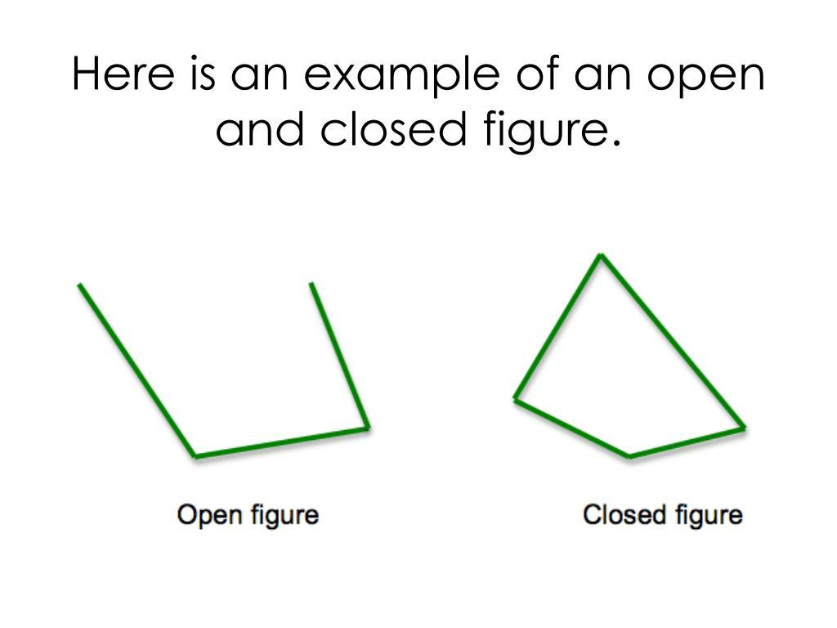
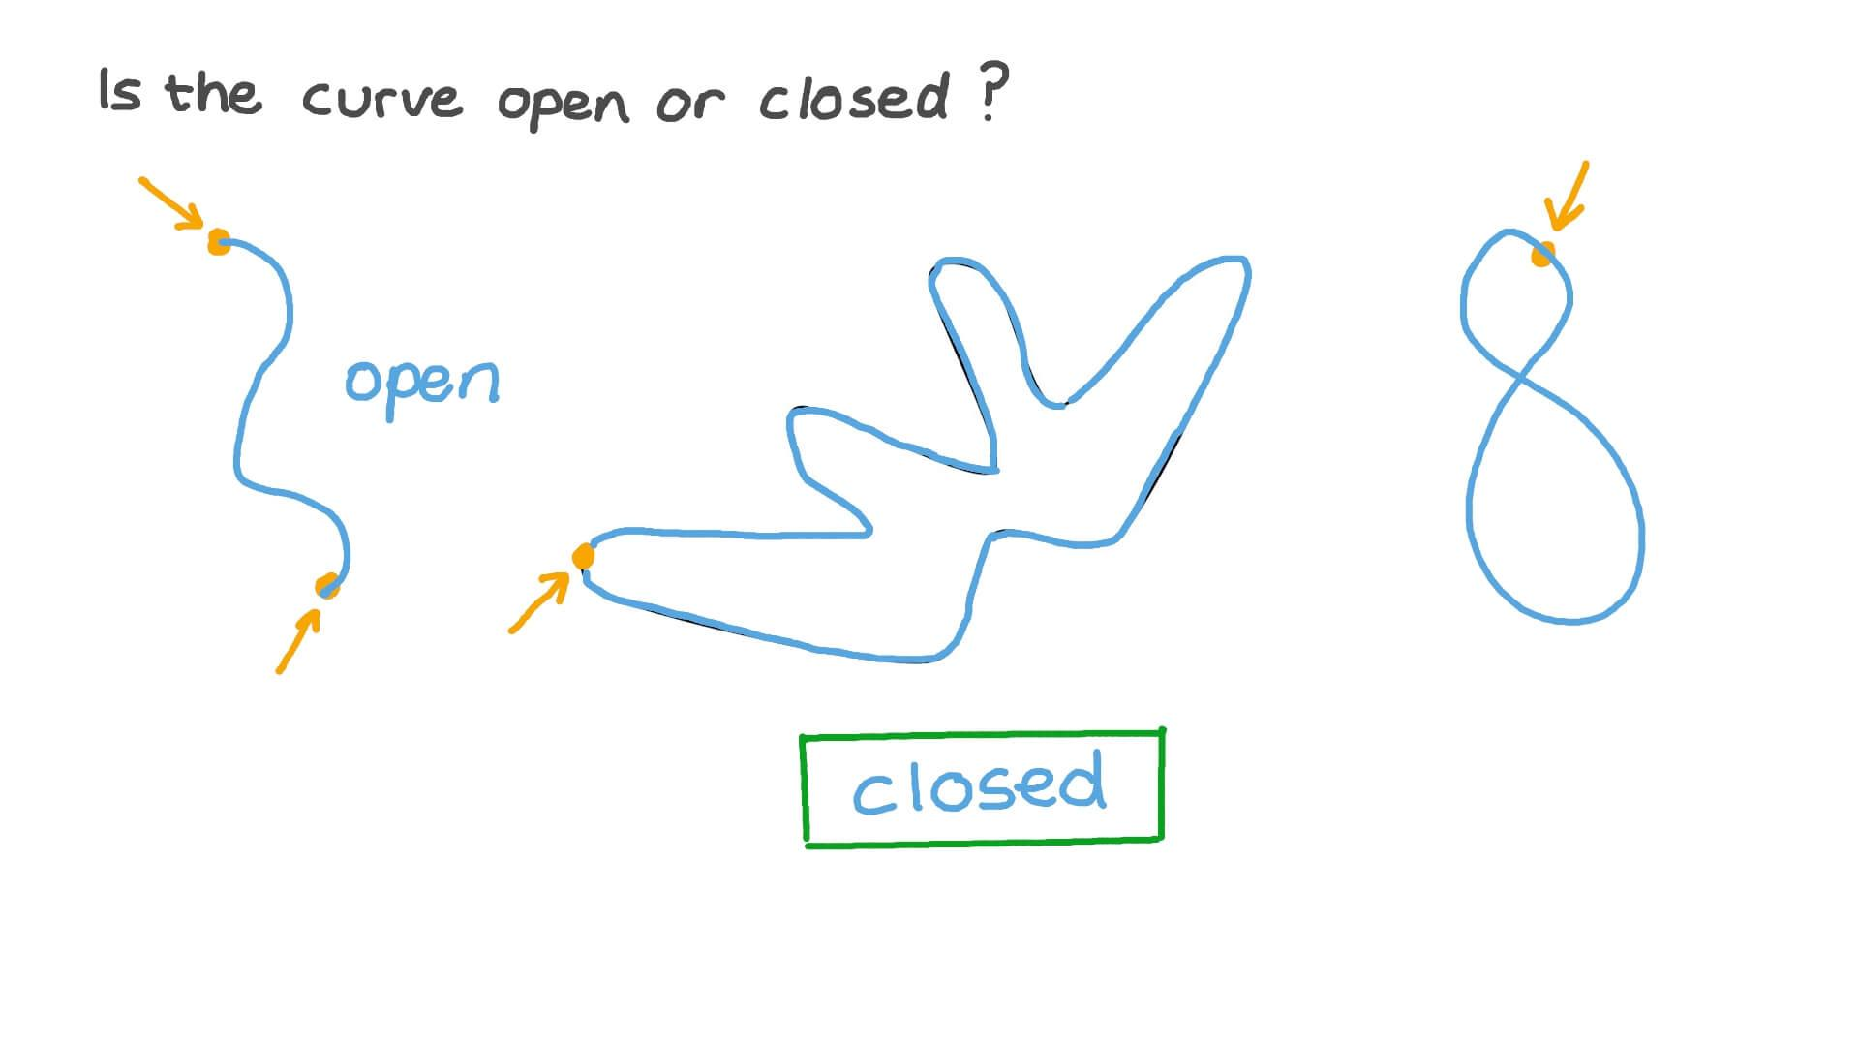
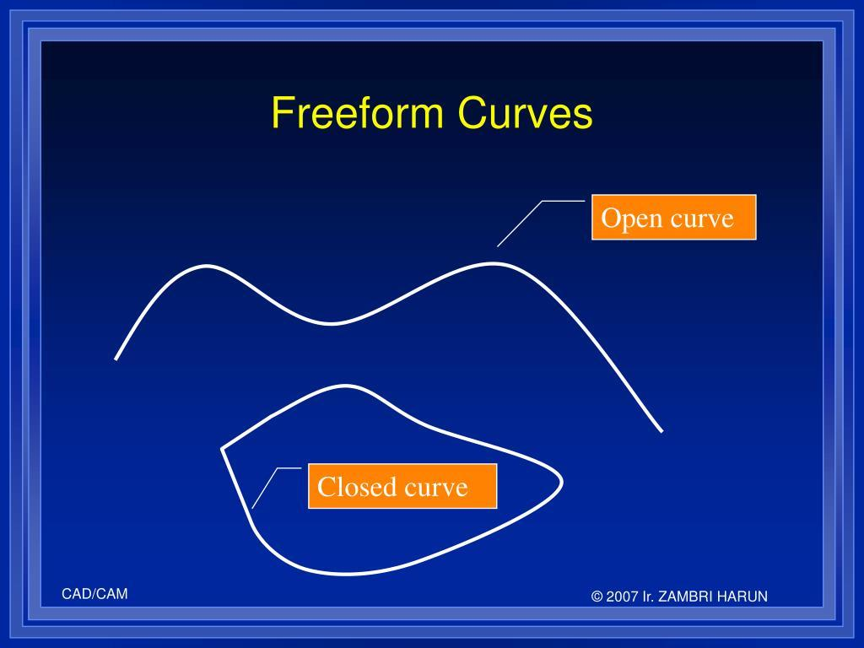
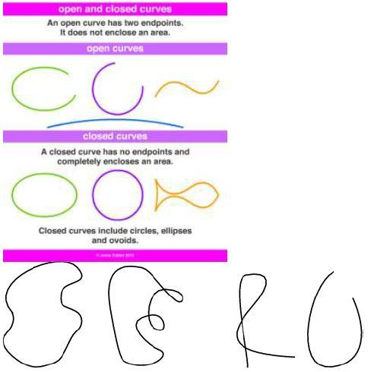

Freeform Shapes vs Geometric Shapes
# Source: AI Source: Provided by: [Data Path: Persons Table -> ID Column: 1, Name_En Column: Motasem Essam] -> From: [ChatGPT] on [7/25/2026]
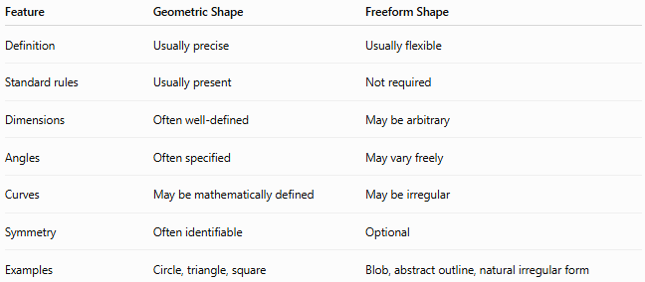
Feature | Geometric Shape | Freeform Shape
Definition | Usually precise | Usually flexible
Standard rules | Usually present | Not required
Dimensions | Often well-defined | May be arbitrary
Angles | Often specified | May vary freely
Curves | May be mathematically defined | May be irregular
Symmetry | Often identifiable | Optional
Examples | Circle, triangle, square | Blob, abstract outline, natural irregular form

Freeform Shapes vs Organic Shapes
# Source: AI Source: Provided by: [Data Path: Persons Table -> ID Column: 1, Name_En Column: Motasem Essam] -> From: [ChatGPT] on [7/25/2026]
These concepts overlap but are not identical.
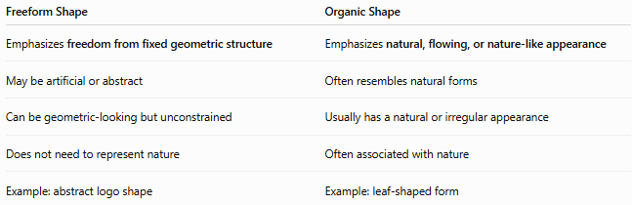
Freeform Shape | Organic Shape
Emphasizes freedom from fixed geometric structure | Emphasizes natural, flowing, or nature-like appearance
May be artificial or abstract | Often resembles natural forms
Can be geometric-looking but unconstrained | Usually has a natural or irregular appearance
Does not need to represent nature | Often associated with nature
Example: abstract logo shape | Example: leaf-shaped form
Therefore:
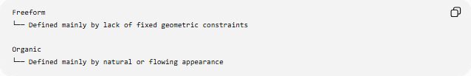
Freeform
└── Defined mainly by lack of fixed geometric constraints

Organic
└── Defined mainly by natural or flowing appearance
A shape can be both freeform and organic.

Mathematical Perspective
# Source: AI Source: Provided by: [Data Path: Persons Table -> ID Column: 1, Name_En Column: Motasem Essam] -> From: [ChatGPT] on [7/25/2026]
"Freeform shape" is generally a descriptive classification, rather than one strict mathematical class.
A freeform boundary can be represented mathematically using:
- Parametric curves
- Bézier curves
- Splines
- Piecewise curves
- Arbitrary functions
- Piecewise linear segments
For example, a parametric freeform curve can be represented as:
$$x=x\left(t\right), y=y\left(t\right)$$
where $t$controls the position along the curve.
A complex freeform boundary can also be constructed from several curve segments.

Examples
# Source: AI Source: Provided by: [Data Path: Persons Table -> ID Column: 1, Name_En Column: Motasem Essam] -> From: [ChatGPT] on [7/25/2026]
Common examples include:
- An irregular blob
- A cloud-like outline
- An abstract logo
- A splash of water
- A freehand drawing
- An irregular decorative shape
- A natural leaf outline
- An artistic curved boundary
- An arbitrary combination of curves and straight segments
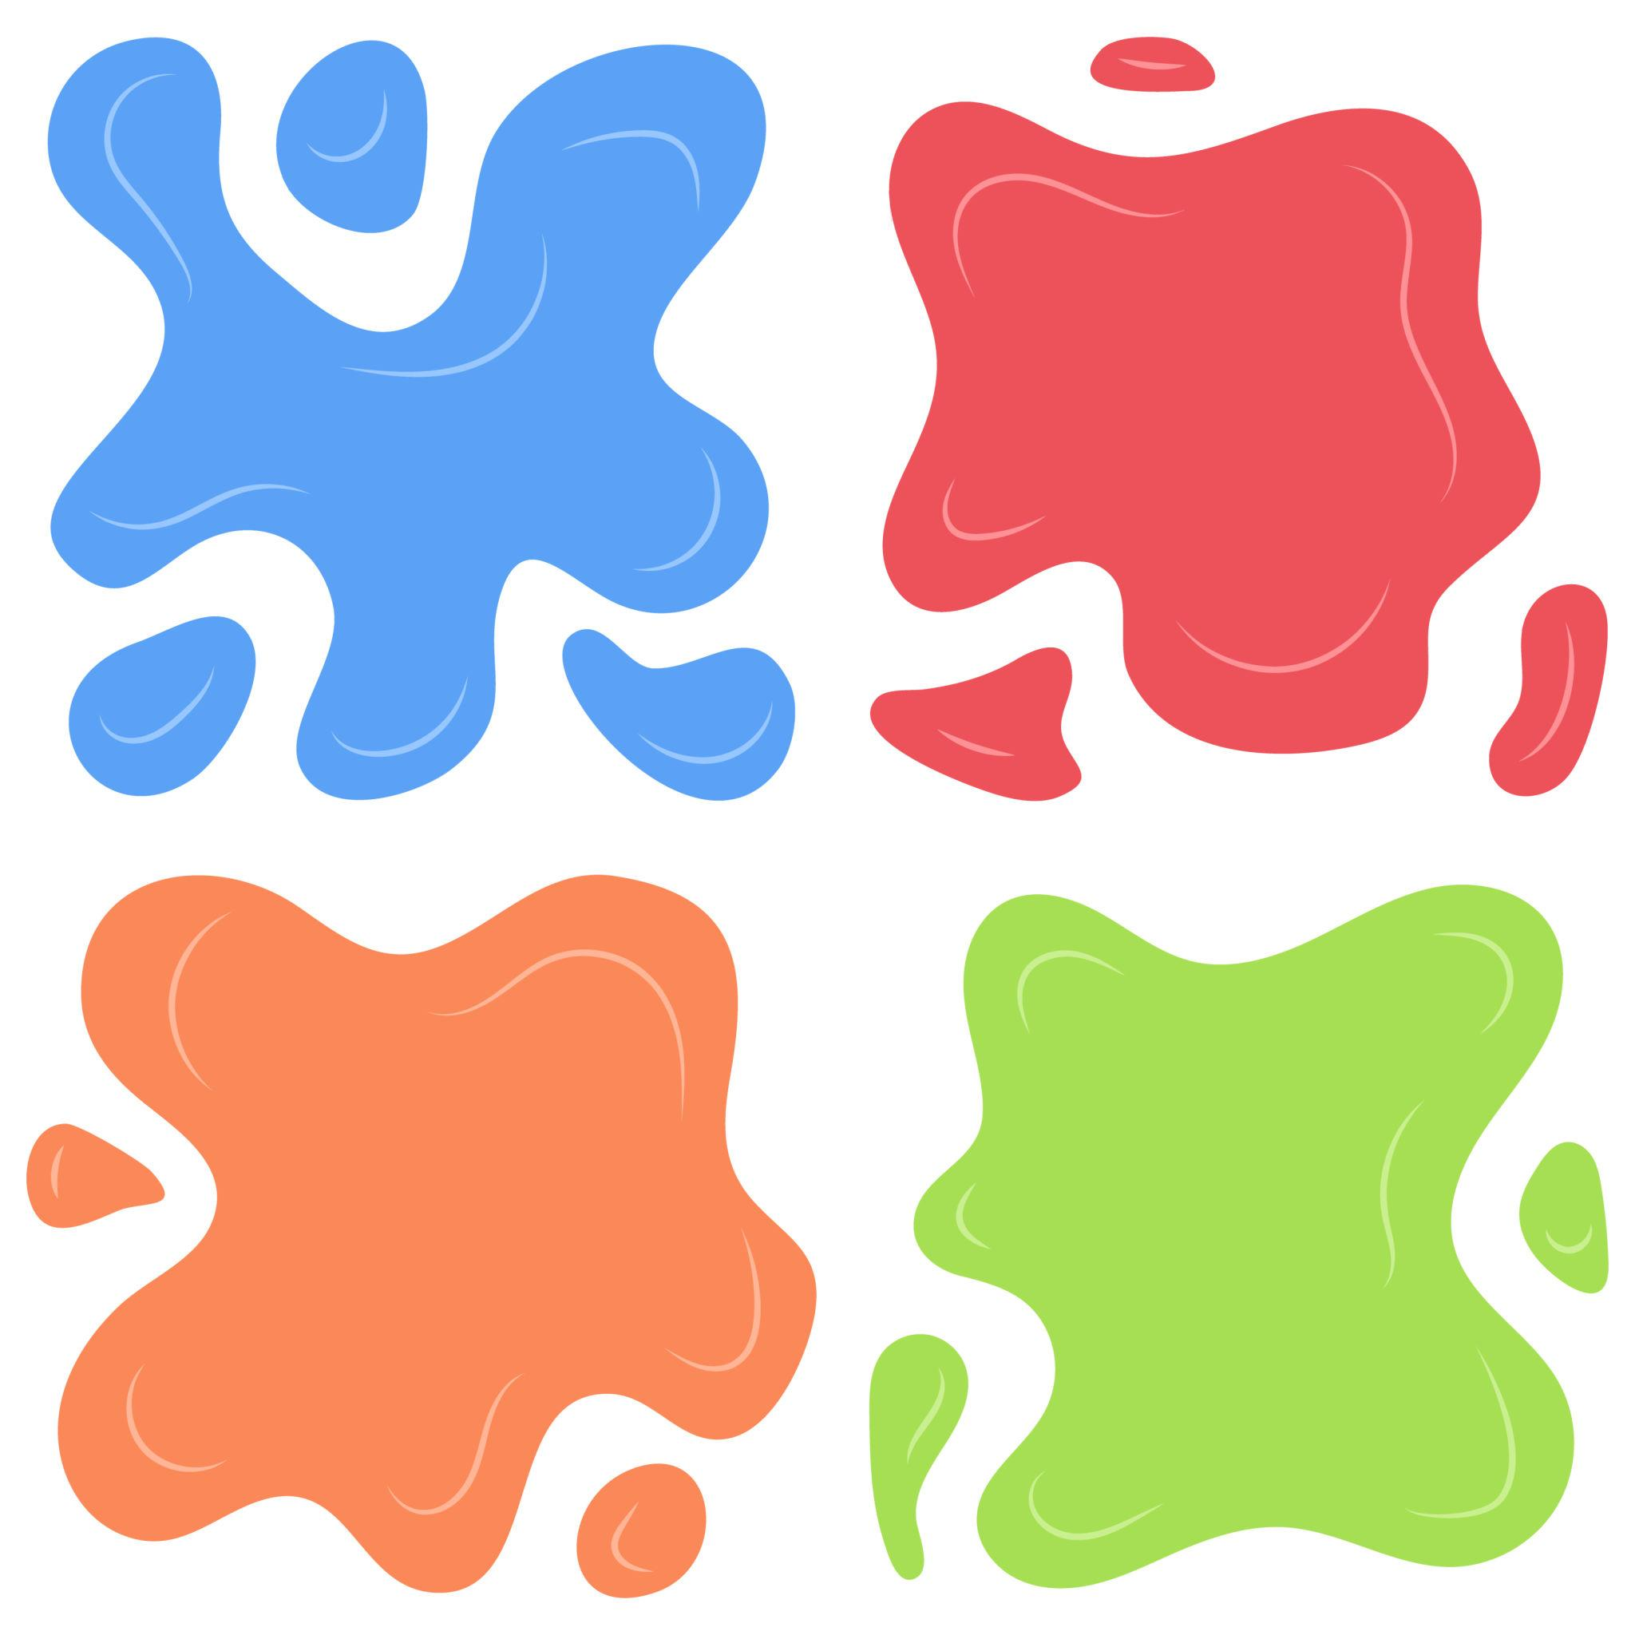
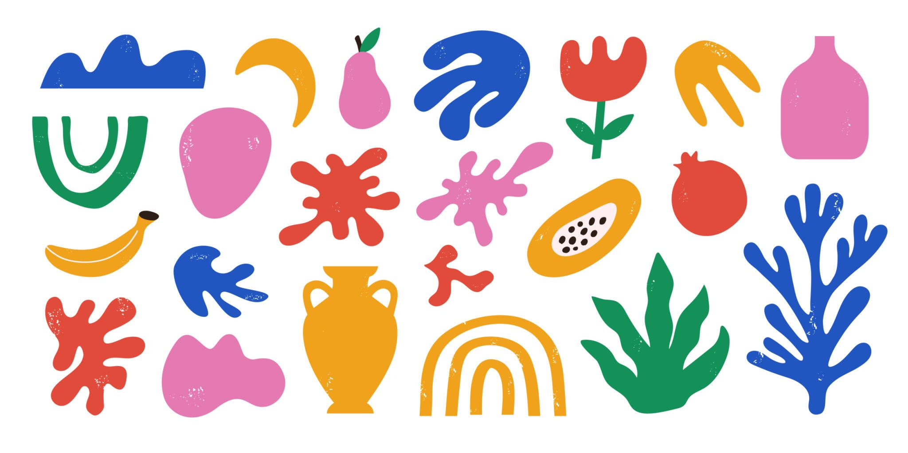
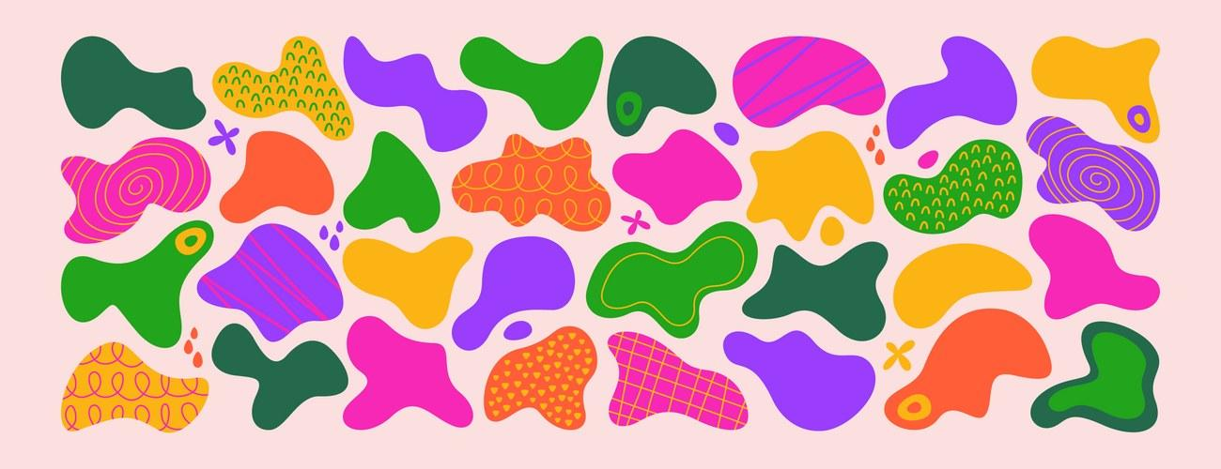
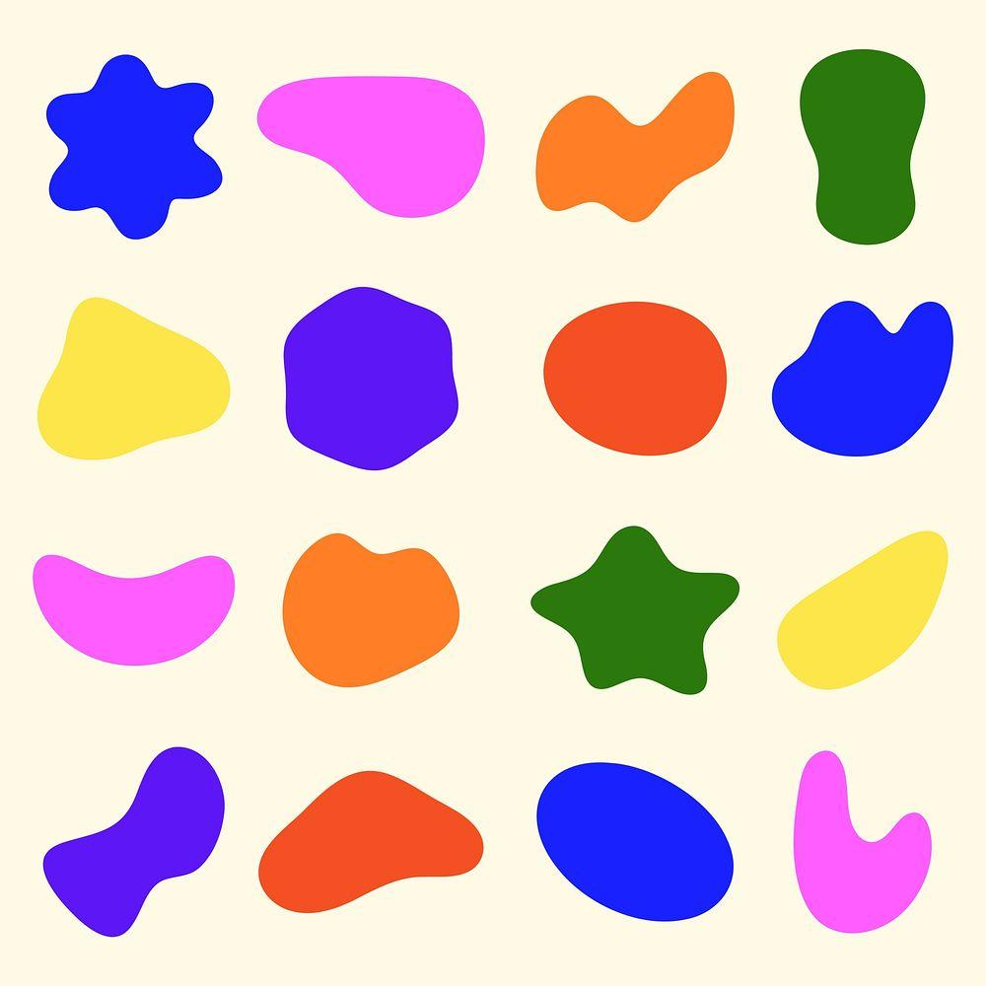
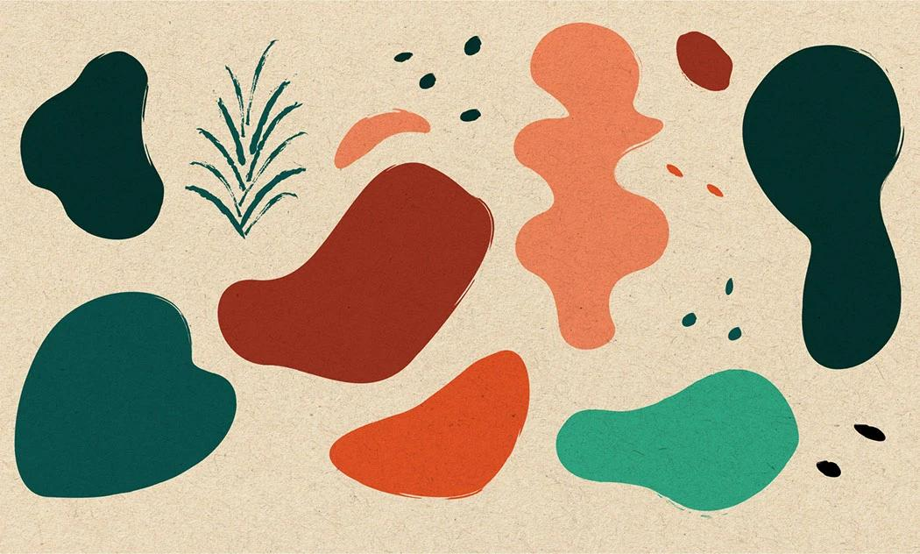

Important Distinction
# Source: AI Source: Provided by: [Data Path: Persons Table -> ID Column: 1, Name_En Column: Motasem Essam] -> From: [ChatGPT] on [7/25/2026]
Freeform does not simply mean "irregular."
For example:
- An irregular pentagon is still a geometric polygon because it has five straight sides.
- A freeform shape does not have to conform to a standard geometric definition.
- A freeform shape can contain regular-looking portions while still being freeform overall.
Thus:
$$\boxed{\text{Irregular Geometric Shape}≠\text{Freeform Shape}}$$
although the two can sometimes visually resemble one another.

Classification Summary
# Source: AI Source: Provided by: [Data Path: Persons Table -> ID Column: 1, Name_En Column: Motasem Essam] -> From: [ChatGPT] on [7/25/2026]
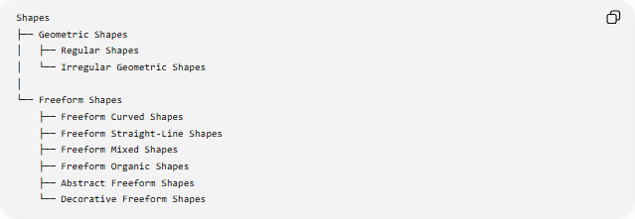
Shapes
├── Geometric Shapes
│ ├── Regular Shapes
│ └── Irregular Geometric Shapes
│
└── Freeform Shapes
├── Freeform Curved Shapes
├── Freeform Straight-Line Shapes
├── Freeform Mixed Shapes
├── Freeform Organic Shapes
├── Abstract Freeform Shapes
└── Decorative Freeform Shapes
Freeform shapes can additionally be:
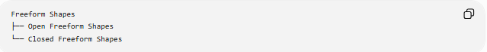
Freeform Shapes
├── Open Freeform Shapes
└── Closed Freeform Shapes

Key Points
# Source: AI Source: Provided by: [Data Path: Persons Table -> ID Column: 1, Name_En Column: Motasem Essam] -> From: [ChatGPT] on [7/25/2026]
- A Freeform Shape has no required standard geometric form.
- Its boundary can be arbitrary or flexible.
- It can contain curves, straight segments, or both.
- It may be open or closed.
- It may be symmetric or asymmetric.
- Freeform shapes are common in art, design, illustration, and natural-form representation.
- Organic shapes are a common type of freeform shape, but the two terms are not synonymous.
- "Freeform shape" is primarily a descriptive classification, not a strict mathematical category.

Conclusion
# Source: AI Source: Provided by: [Data Path: Persons Table -> ID Column: 1, Name_En Column: Motasem Essam] -> From: [ChatGPT] on [7/25/2026]
A Freeform Shape is a flexible, non-standard shape whose boundary is not constrained to a predefined geometric pattern. It provides a broad category for irregular, curved, mixed, abstract, and natural-looking forms that do not fit conventional geometric classifications.

